Objects and its internal representations

Objects in JavaScript is the most important datatype and forms the building blocks for the modern JavaScript. Object is quite different from the primitive data-types of JavaScript as it is reference data-type.

Variables that are assigned a reference value are given a reference or a pointer to that value. That reference or pointer points to the location in memory where the object is stored.

Loosely speaking, Objects can hold many values in form of **property: value pair**.

For example, a car is an object and it has many different properties like Model, Color, Fuel, weight, mileage, etc.

Creating objects in a JavaScript:

1. By object literal
2. By creating instance of Object directly (using new keyword)

**By object literal**

Syntax:



Example:



**By creating instance of Object directly (using new keyword):**

Syntax:



Example:

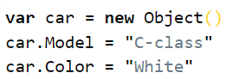

Accessing JavaScript Object:

objectName.property



Or

objectName[“property”]

